Progression in Calculations
Addition
Key Language: sum, total, parts and wholes, plus, add, altogether, increase, more, ‘is equal to’, ‘is the same as’, addend
Objective and Strategies | Concrete | Pictorial | Abstract
Adding 1 more than… | 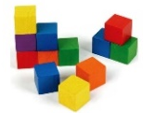  Use cubes or other resources available to add 1 more. | 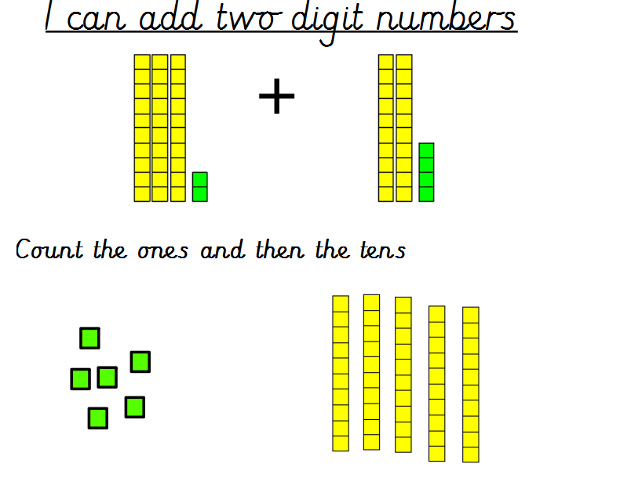  Use pictures of dienes or sticks and dots  10 + 1 = 11  Use a bar model  5 = 3 + 2 | 5 + 1 = 6  + 1 = 6  6 = ? + 1  x = 5 + 1
  6
Combining two parts to make a whole: part- whole model | Use cubes to add two numbers together as a group or in a bar.  8  1 | 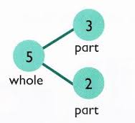  5 = 3 + 2  Use the part-part whole diagram.    3 + 2 = 5  Use pictures to add two numbers together as a group or in a bar.  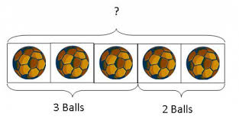  8 + 1 = 9  Use a bar model  6 = 2 + 4  2 4 | 4 + 3 = 7  10= 6 + 4  5  3  Use the part-part whole diagram as shown above to move into the abstract.
  6
  2 | 4
  6
Starting at the bigger number and counting on | 12 + 5 = 17  Start with the larger number on the bead string and then count on to the smaller number 1 by 1 to find the answer.  Use of dienes  40 + 6 = 46  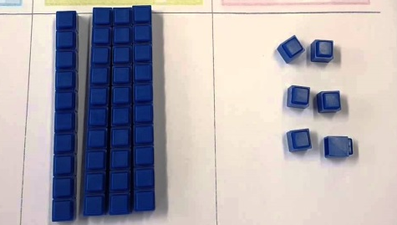  Use of a counting stick  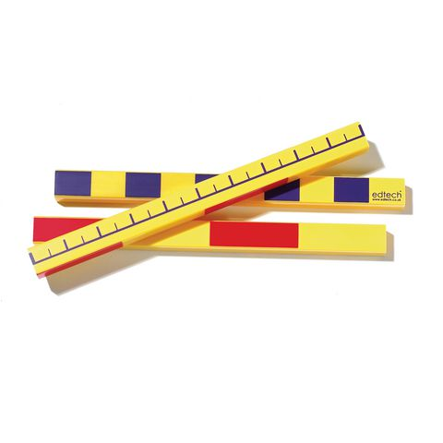 | 12 + 5 = 17  + 5  + 1 +1 +1 +1 +1  Start at the larger number on the number line and count on in ones or in one jump to find the answer.  Use of a counting stick diagram  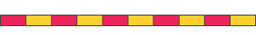 | 5 + 12 = 17  17 = 5 + ?  17 = + 2  a = 5 + 2  Place the larger number in your head and count on the smaller number to find your answer.  What is 2 more than 4?  What is the sum of 2 and 4?  What is the total of 4 and 2?  Increase 4 by 2.
Regrouping to make 10. | 6 + 5 = 11  Use bead strings and tens frames to start with the bigger number and use the smaller number to make 10.  Use of dienes, adding with single cubes, until ten ones can be exchanged for one ten stick (reinforcement of place value too!)  6 + 5 = 11  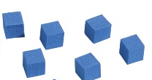 + 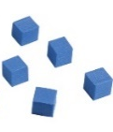  changes to  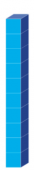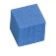 | Use pictures or a number line. Regroup or partition the smaller number to make 10.  2  1  6 + 5 = 11  Use of bar model.  6 4 1  5 | 7 + 4= 11  1  3  If I am at seven now, how many more years do I need to add on to make 10. How many more do I still need to add on now to make 11?  7 + ? = 11  7 + 4 = 4 +  7 + 4 = x + 3
  11
Adding three single digits | 4 + 7 + 6 = 17  Put 4 and 6 together to make 10. Add on 7.  Following on from making 10, make 10 with 2 of the digits (if possible) then add on the third digit.  Add together three groups of objects. Draw a picture to recombine the groups to make 10.  Use dienes 5 + 6 + 1 = 12  Use of a bar model to show part, part, whole.  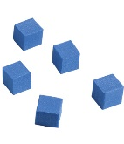  Use a counting stick as a number line  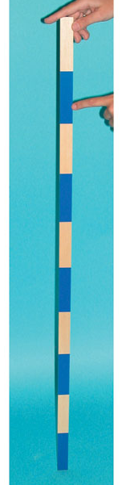 |         1  6  5  +  +  + | Combine the two numbers that make 10 and then add on the remainder.
  12
Column method- no regrouping | 24 + 15= 39  Add together the ones first then add the tens. Use the Base 10 blocks first before moving onto place value counters.  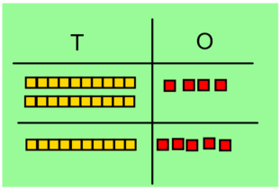  44 + 15 = 59  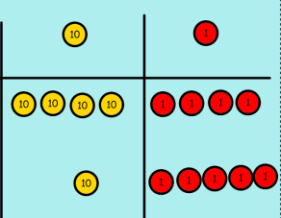 | After practically using the base 10 blocks and place value counters, children can draw the counters to help them to solve additions.  32 + 13 = 55  T O  32 + 13 = 55  Use of sticks and dots  Use of bar models for missing boxes and number lines to check. | 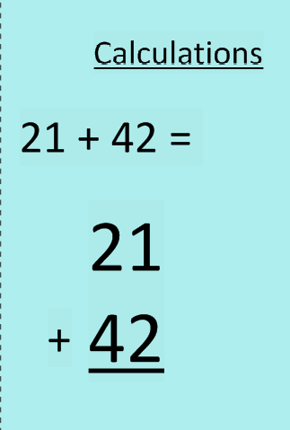
  15
  7 | ?
Column method- regrouping | Make both numbers on a place value grid.  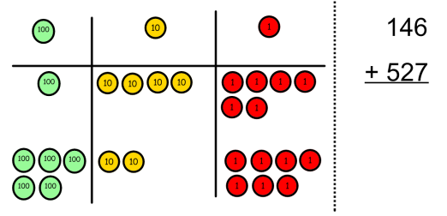  Add up the ones and exchange 10 ones for one 10.  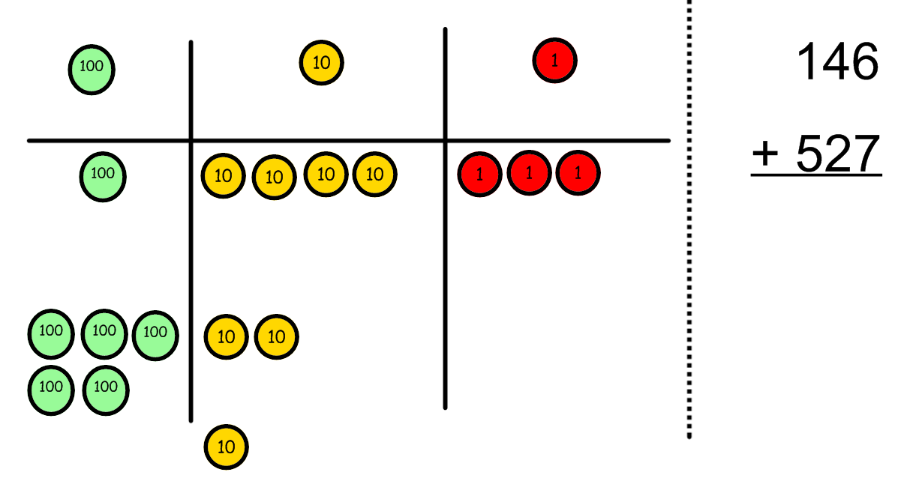  Add up the rest of the columns, exchanging the 10 counters from one column for the next place value column until every column has been added.  This can also be done with Base 10 to help children clearly see that 10 ones equal 1 ten and 10 tens equal 100.  36 + 25 = 61  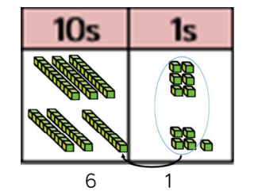  As children move on to decimals, money and decimal place value counters can be used to support learning. | Children can draw a pictoral representation of the columns and place value counters to further support their learning and understanding.  2634 + 4517 = 7151  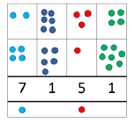  Use of sticks and dots  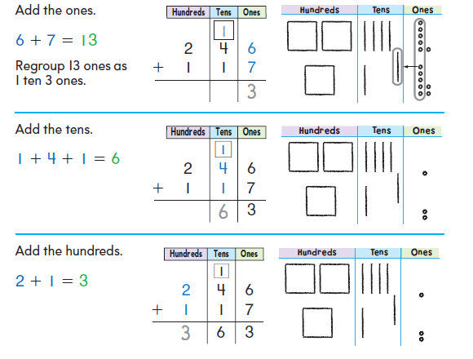 | Start by partitioning the numbers before moving on to clearly show the exchange below the addition.  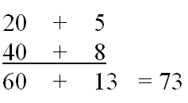  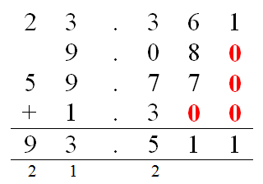  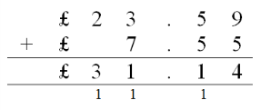  As the children move on, introduce decimals with the same number of decimal places and different. Money can be used here.

Notes
- Bar models can be used for missing box problems with most of the objectives.
- Number lines should be used for time problems, involving addition and subtraction.

Subtraction
Key Language: subtrahend, take away, less, difference, subtract, minus, fewer, decrease.
Objective and Strategies | Concrete | Pictorial | Abstract
Taking away ones | Use physical objects, counters, cubes etc to show how objects can be taken away.      6 – 2 = 4  Use dienes 13 – 4 = 9  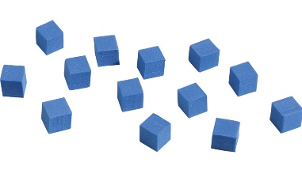  Use of counting sticks | Cross out drawn objects to show what has been taken away.  Draw dienes representations  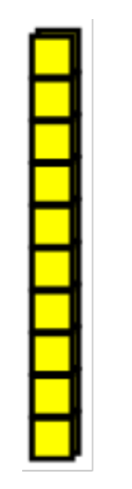10 - 3 = 7  Use of sticks and dots  25 - 4 = 21  Use of a number line  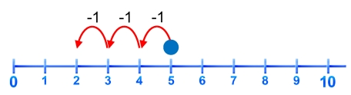 5 – 3 = 2 | 18 – 3 = 15  8 – 2 = 6  Missing box ideas  8 - = 6  8 - ? = 6  8 – y = 6  and reversal of the algorithm  6 = 8 -  6 = 8 - ?  6 = 8 – y  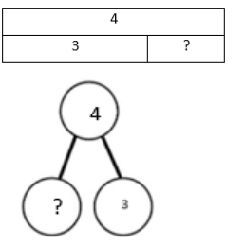
Counting back | 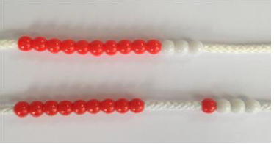  Make the larger number in your subtraction. Move the beads along your bead string as you count backwards in ones.  13 – 4  Use counters and move them away from the group as you take them away counting backwards as you go.  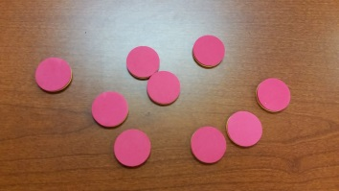  Use of dienes  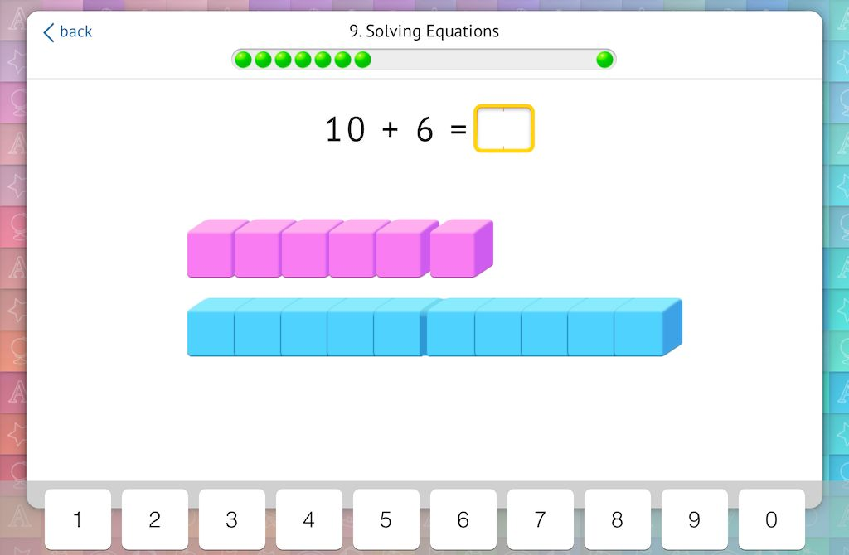  6 - 1 = 5  10 - 5 = 5 | Count back on a number line or number track  13 – 4 = 9  -1 -1 -1 -1  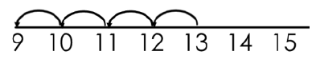  Start at the bigger number and count back the smaller number showing the jumps on the number line.  57 – 23 = 34  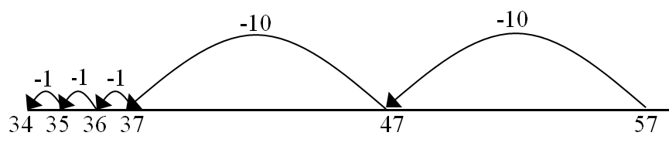  This can progress all the way to counting back using two 2 digit numbers. | Put 13 in your head, count back 4. What number are you at? (Children can use their fingers if this helps).  13 - 2 = 11  11 = 13 - 2  What is 2 less than 13?  Decrease 13 by 2.
Find the difference | 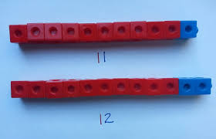  Compare amounts and objects to find the difference.  Use cubes or dienes to build towers or make bars to find the difference.  Use basic bar models with items to find the difference. | Use of number lines  Count on to find the difference between two numbers.  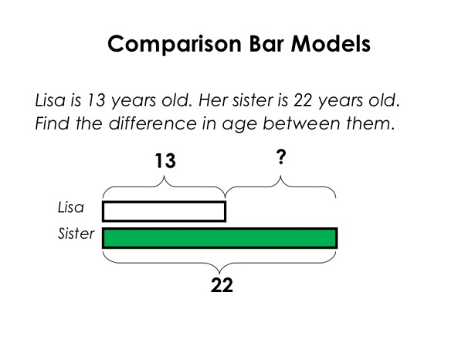  Comparison bar models  Draw bars to find  the difference between 2 numbers. | Hannah has 23 sandwiches, Helen has 15 sandwiches. Find the difference between the number of sandwiches.  What is the difference between 13 and 2?  Why do these algorithms have the same difference?  9 – 6 = 8 – 5 = 7 - 4
Part-Part Whole Model | Link to addition- use the part-part whole model to help explain the inverse between addition and subtraction.  If 10 is the whole and 6 is one of the parts. What is the other part?  10 - 6 =  Use of dienes 9 - 5 = 4  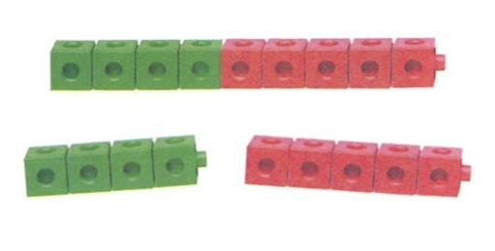 |     Use a pictorial representation of objects to show the part- part whole model.  2  6 ?  Use of bar models  2 4 | 10  5  Move to using numbers within the part whole model.
  6
Make 10 | 14 – 9 =  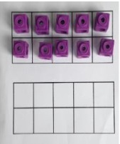  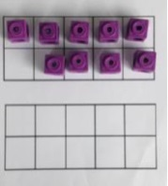  Make 14 on the tens frame. Take away the four first to make 10 and then takeaway one more so you have taken away 5. You are left with the answer of 9.  Use of dienes  13 - 5 =  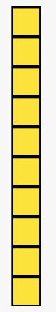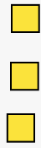  - 2 - 3  13 - 3 - 2 = 8 | Use of number lines  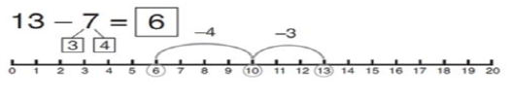  Start at 13. Take away 3 to reach 10. Then take away the remaining 4 so you have taken away 7 altogether. You have reached your answer. | 16 – 8=  Partition the subtrahend (quantity being subtracted from another quantity – 8)  How many do we take off 16 to reach the next 10?  How many more do we have left to take off?
Column method without regrouping | Use Base 10 to make the bigger number then take the smaller number away.  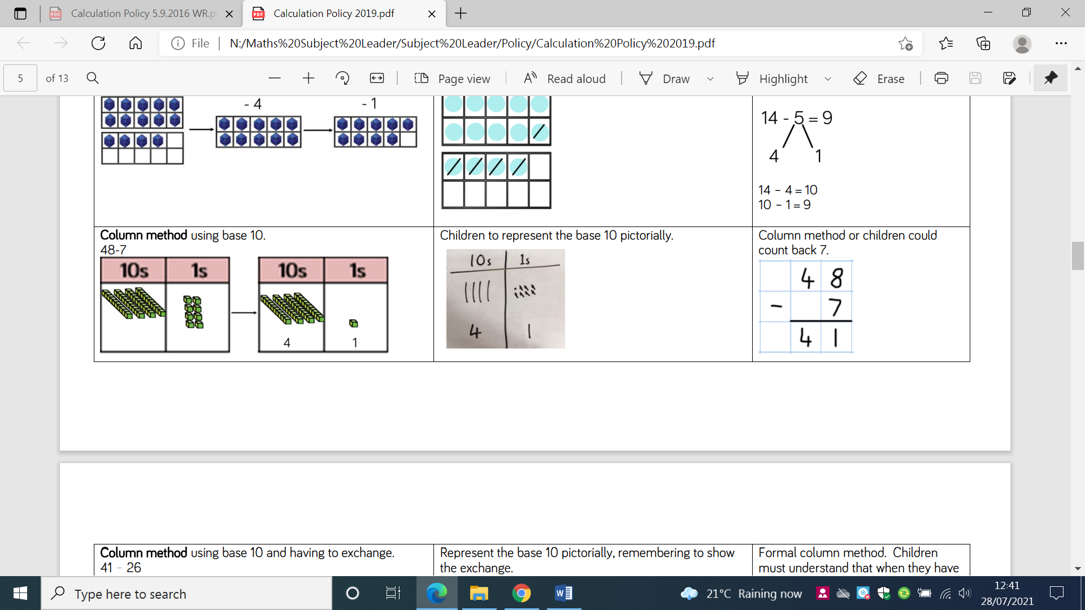  Show how you partition numbers to subtract by the side. T O  40 8  - 7  40 1 | 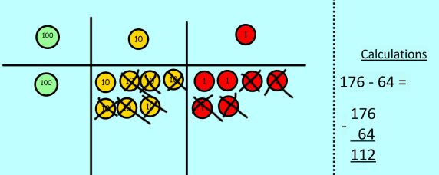  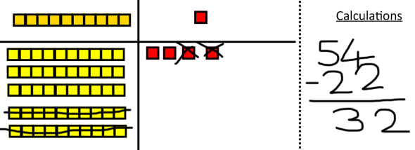  Draw the Base 10 or place value counters alongside the written calculation to help to show working.  Sticks and dots subtraction and use of number line to check answers.  55 - 23 = | 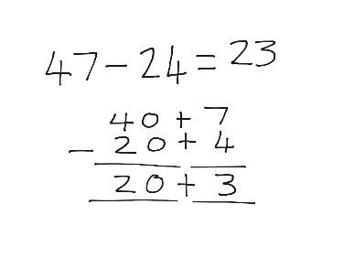  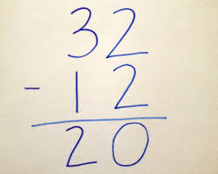  This will lead to a clear written column subtraction.
Column method with regrouping | Use Base 10 to start with before moving on to place value counters. Start with one exchange before moving onto subtractions with 2 exchanges.  Make the larger number with the place value counters  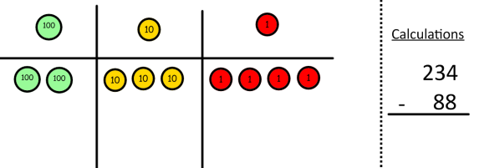  Start with the ones, can I take away 8 from 4 easily? I need to exchange one of my tens for ten ones.  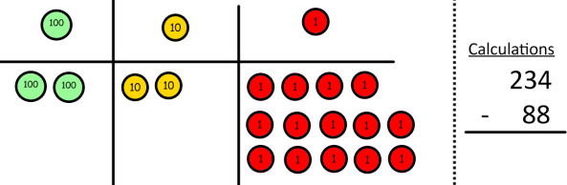  Now I can subtract my ones.  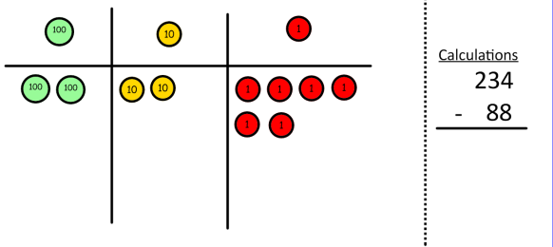  Now look at the tens, can I take away 8 tens easily? I need to exchange one hundred for ten tens.  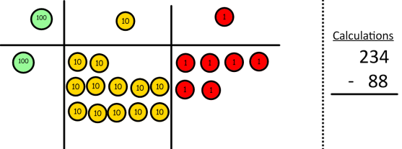  Now I can take away eight tens and complete my subtraction  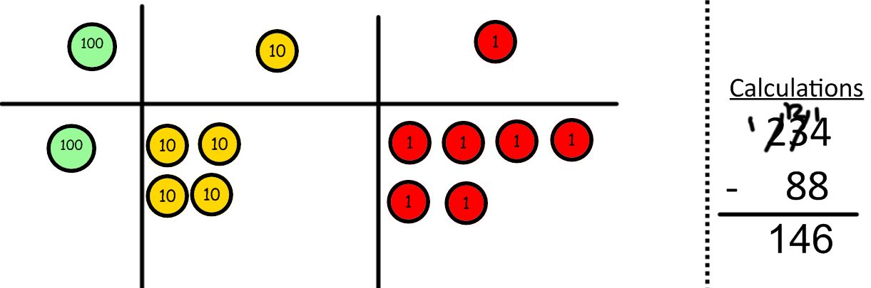  Show children how the concrete method links to the written method alongside your working. Cross out the numbers when exchanging and show where we write our new amount. | 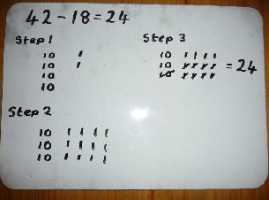  Draw the counters onto a place value grid and show what you have taken away by crossing the counters out as well as clearly showing the exchanges you make.  When confident, children can find their own way to record the exchange/regrouping.  Just writing the numbers as shown here shows that the child understands the method and knows when to exchange/regroup.  Sticks and dots  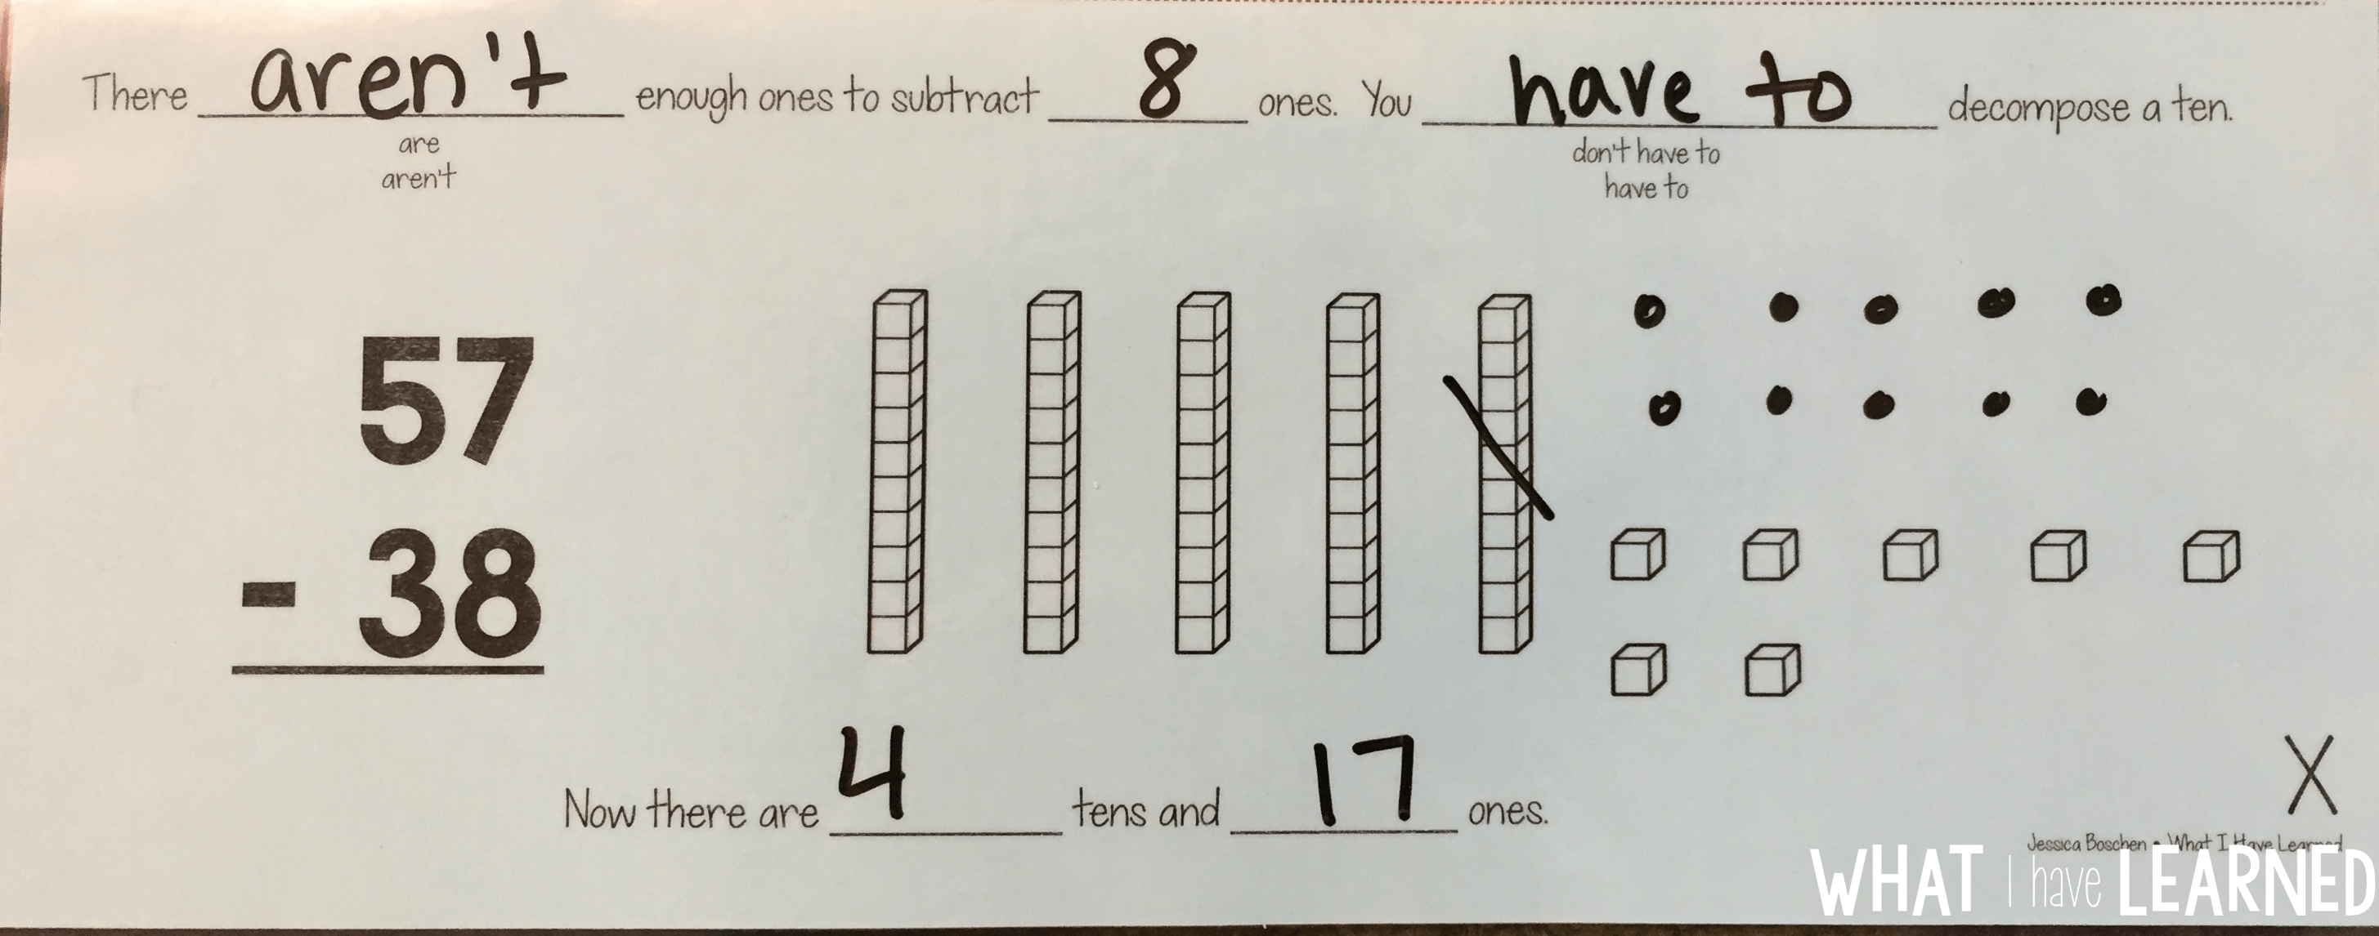 | Children can start their formal written method by partitioning the number into clear place value columns.  Moving forward the children use a more compact method.  This will lead to an understanding of subtracting any number including decimals.
Notes
- Bar models can be used for missing box problems with most of the objectives.
- Number lines should be used for time problems, involving addition and subtraction.

Multiplication
Key Language: double, times, multiplied, product, groups, lots, of, commutativity
Objective and Strategies | Concrete | Pictorial | Abstract
Doubling | 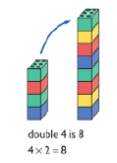  Use practical activities to show how to double a number.  Use of dienes  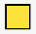  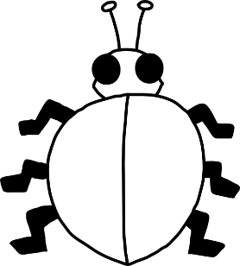  double 2 double 3  2 x 2 = 4 3 x 2 = 6 | Draw pictures to show how to double a number. Reinforce knowledge of the 2 times tables.  Diagrams to add dots or sticks to.  double 2 is 4 double 3 is 6 | 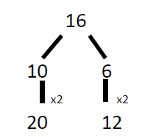  Partition a number and then double each part before recombining it back together.  3 + 3 = 3 x 2 = 2 x 3
Doubling with double-digit numbers (KS2) | Use dienes  With no exchanging. Double 32.  With exchanging of the ones. Double 28.  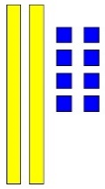  becomes | Use of sticks and dots to help with exchange process.  Double 35  = | What is double 23?  What is double 47?  What is double 87?
Counting in multiples | 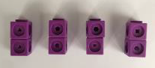  Count in multiples supported by concrete objects in equal groups.  Use of dienes on a mat | Use a number line or pictures to continue support in counting in multiples.  Show the multiples in arrays  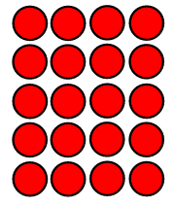 5, 10, 15, 20  Use a counting stick to reinforce counting in multiples (Times Tables in 10 minutes video) | Count in multiples of a given number aloud.  Write sequences with multiples of numbers which for forward and backward  2, 4, 6, 8, 10  10, 8, 6, 4, 2  5, 10, 15, 20, 25, 30  30, 25, 20, 15, 10, 5  ‘I have 12 cubes and each row has 4 cubes – how many rows are there?’
  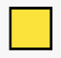
Repeated addition | 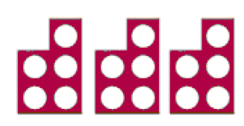  Use different objects to add equal groups.  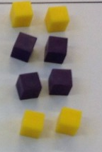  Use of dienes  to make arrays |   Use of number lines  Use of bar models to show repeated addition | Write addition sentences to describe objects and pictures. What do they notice?
  ?
  ?
  2 | 2 | 2
Arrays- showing commutative multiplication | Create arrays using counters/ cubes to show multiplication sentences.  4 lots of 6 = 4 x 6 = 24  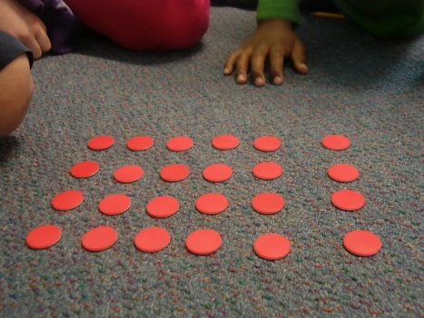  3 lots of 5 = 3 x 5 = 15 | Draw arrays in different rotations to find commutative multiplication sentences.  2 lots of 4 (2 x 4) is the same as 4 lots of 2 (4 x 2).  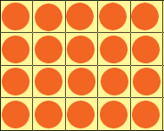  Link arrays to area of rectangles.  4 lots of 5 = 20  4 x 5 = 20  Encourage the children to describe rectangles using appropriate language and to recognise that a 5 x 4 rectangle is the same as a 4 x 5  5 x 4 4 x 5 | 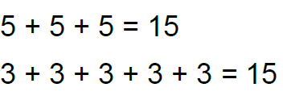  Use an array to write multiplication sentences and reinforce repeated addition.  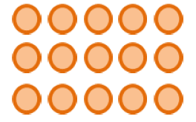
Using the inverse should be taught alongside multiplication so that they learn how they work alongside each other | 2 lots of 4 are 8  8 divided by 2 is 4  8 divided by 4 is 2  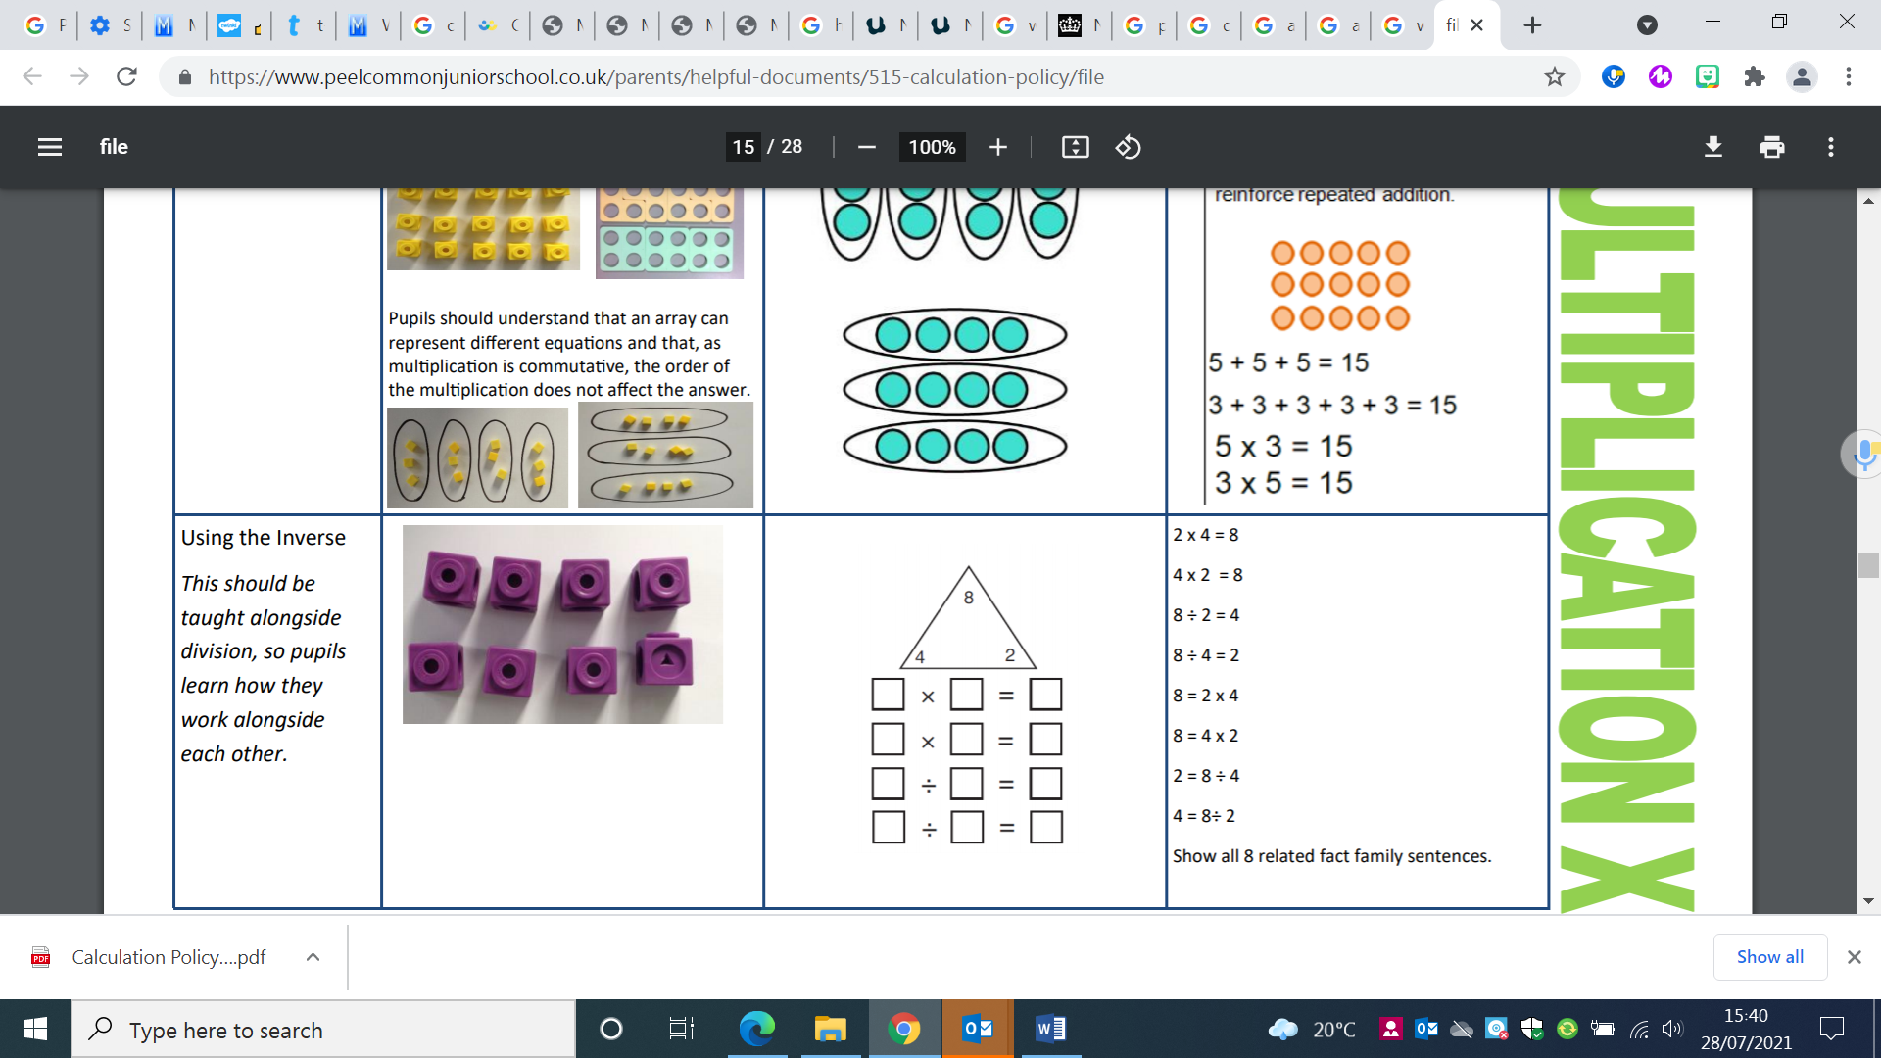 | Fact families
Finding out about rectangles (KS2) | Use of dienes and arrays to investigate square numbers and prime numbers  ‘A square number is called a square number because you can make a square with it!’  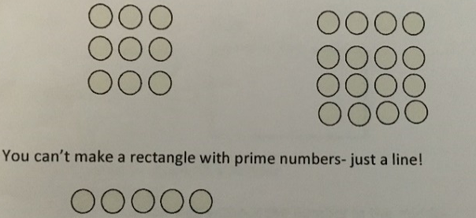 | Using arrays to investigate numbers  ‘Is 25 a square number?’ Why is 5 a prime number? | What is the square root of 25?  5² = ?
Grid Method | Show the link with arrays to first introduce the grid method.  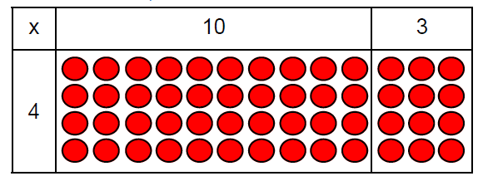  4 rows of 10  4 rows of 3  Move on to using Base 10 to move towards a more compact method.  4 rows of 13  (arrays)  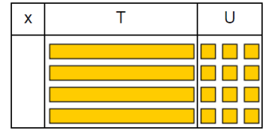  Move on to place value counters to show how we are finding groups of a number.We are multiplying by 4 so we need 4 rows.  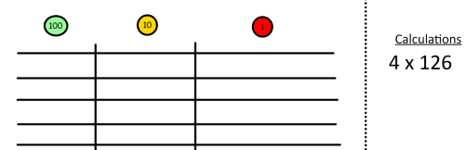  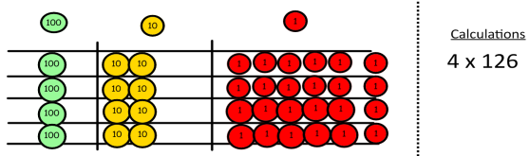  Fill each row with 126.  Add up each column, starting with the ones making any exchanges needed.  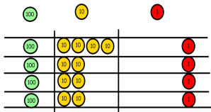  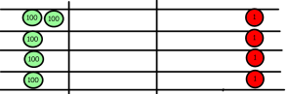  Then you have your answer.  4 x 126 = 504 | Children can represent the work they have done with place value counters in a way that they understand.  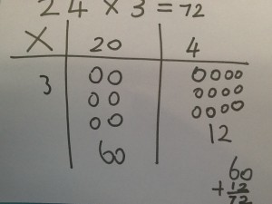  They can draw the counters, using colours to show different amounts or just use circles in the different columns to show their thinking as shown below.  Bar models can be used to explore missing numbers.  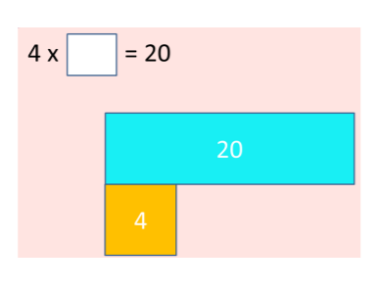 | Start with multiplying by one digit numbers and showing the clear addition alongside the grid. Reinforce knowledge of known times tables facts.  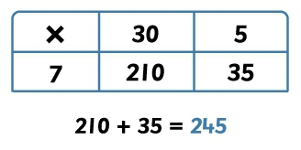  Moving forward, multiply by a 2 digit number showing the different rows within the grid method.  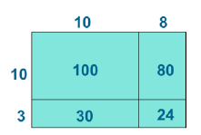  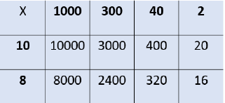
Column multiplication | 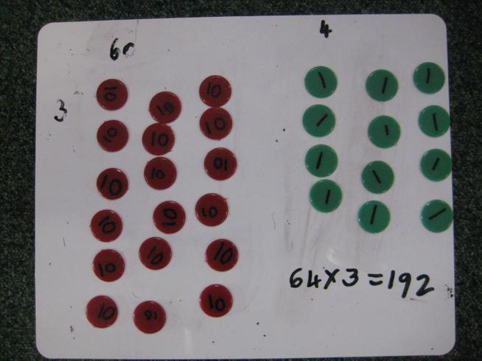  Children can continue to be supported by place value counters at the stage of multiplication.  It is important at this stage that they always multiply the ones first and note down their answer followed by the tens which they notbelow. | Bar modelling and number lines can support learners when solving problems with multiplication alongside the formal written methods.  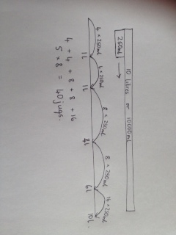  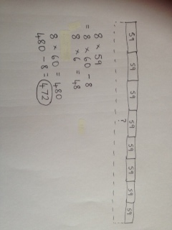 | Start with long multiplication, reminding the children about lining up their numbers clearly in columns.  If it helps, children can write out what they are solving next to their answer.  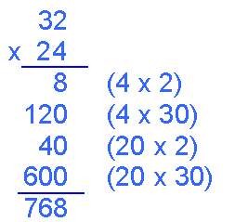  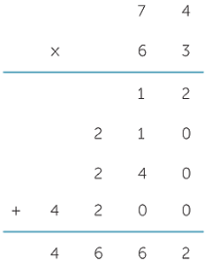  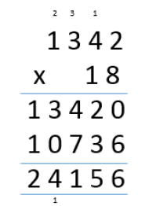  This moves to the more compact method.  This can be extended to decimal numbers.

Learning multiplication facts
- Display of real-life images relating to times tables facts
- Array models using dots or squares and real-life array images
- Look for patterns and connections
- Retrieval practice: games, counting stick (Times Tables in 10 minutes video), manipulatives, computer based quick reaction games
- Ask the children to cut rectangles from squared paper to represent a set of multiplication/division facts
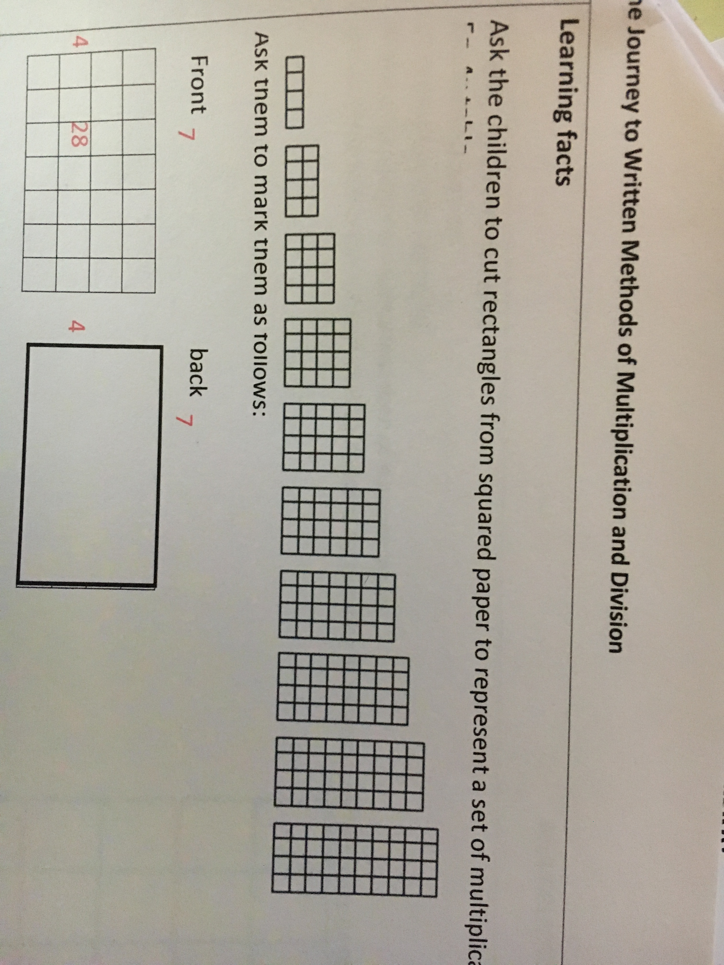
- Write the dimensions on the back and the product on the front. Play with a partner, showing them the side without the product in the middle. Any the partner cannot work out, they can take home to learn.

- Commutative and inverse facts, mini and mega facts: 70 x 4 = 280 and 0.7 x 4 = 2.8, distributive law: (5 x 4) + (2 x 4) = 7 x 4, doubling and halving facts and know that 4 x 7 is the same as (5 x 7) – 7.

Division
Key Language: share, group, divide, divided by, halve, dividend, divisor, quotient, factor.
Objective and Strategies | Concrete | Pictorial | Abstract
Sharing objects into groups | 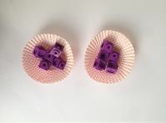  I have 10 cubes, can you share them equally in 2 groups?  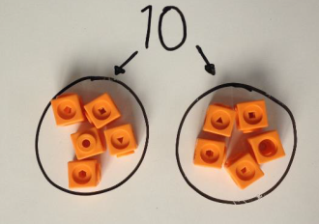  Use of dienes to support sharing objects. | Children use pictures or shapes to share quantities.    8 ÷ 2 = 4 | Share 9 buns between three people.  9 ÷ 3 = 3
Division as grouping | Divide quantities into equal groups.  Use cubes, counters, objects or place value counters to aid understanding.  Use of arrays  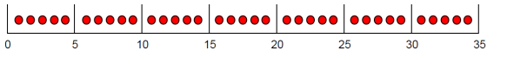  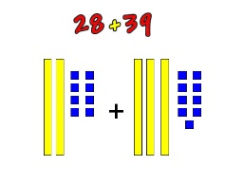  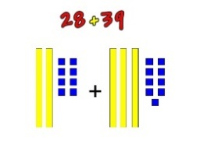  Use of dienes  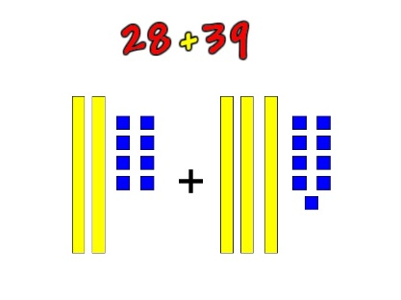  36 ÷ 3 = 12 | Use a number line to show jumps in groups. The number of jumps equals the number of groups.  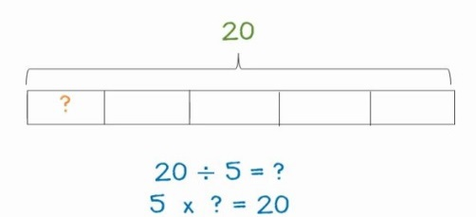  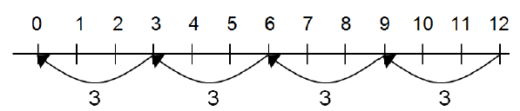  Think of the bar as a whole. Split it into the number of groups you are dividing by and work out how many would be within each group.  Use of bar models | 28 ÷ 7 = 4  Divide 28 into 7 groups. How many are in each group?  Calculate 1/7 of 28?  Calculate ¼ of 28?
Division within arrays | 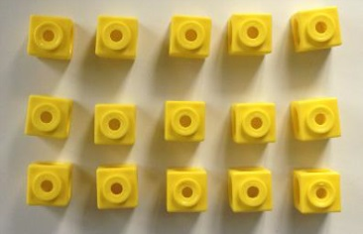  Link division to multiplication by creating an array and thinking about the number sentences that can be created.  Use of dienes  Eg 15 ÷ 3 = 5 5 x 3 = 15  15 ÷ 5 = 3 3 x 5 = 15 | 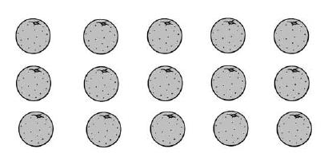  Draw an array and use lines to split the array into groups to make multiplication and division sentences. | Find the inverse of multiplication and division sentences by creating four linking number sentences.  7 x 4 = 28  4 x 7 = 28  28 ÷ 7 = 4  28 ÷ 4 = 7
Halving (KS2) | Use of dienes  To halve a 2-digit even number no exchanging.  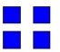  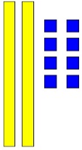  48 ÷ 2  To halve a 2-digit number with an exchange of a ten  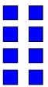  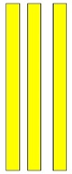  38 ÷ 2  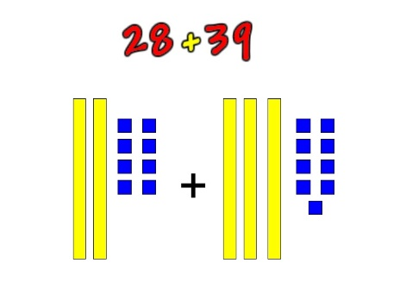  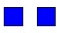  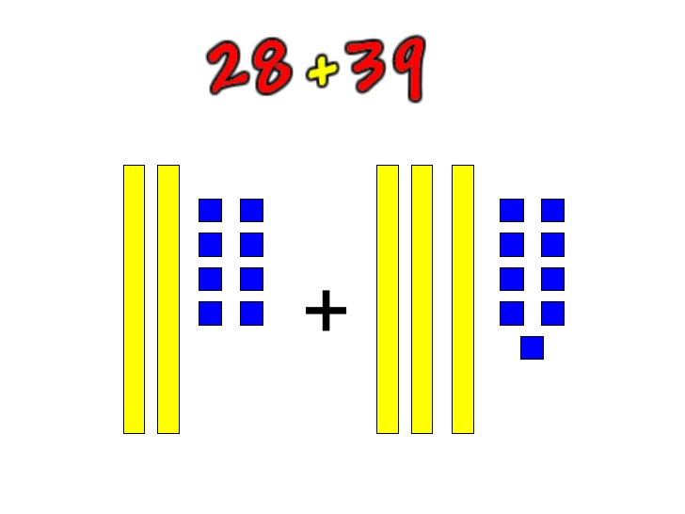 =  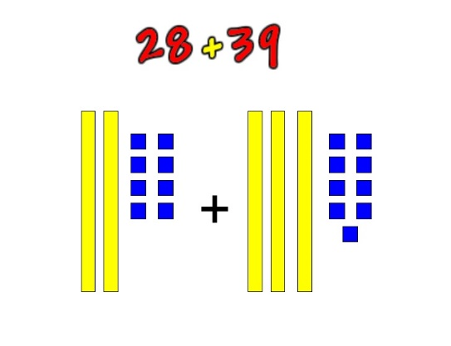  To halve a 2-digit number with an exchange of a ten and with a remainder.  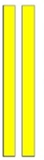  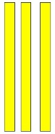  55 ÷ 2  becomes | Use of bar model to represent halves | What is half of …?  ½ of 48 = ?  ½ x 48 =  0.5 x 48 = ?  50% of 48 =
  48
  24 | 24
Finding factors | Use dienes to represent factors  This can be extended to decimal numbers with place value counters or dienes to represent tenths and hundredths.  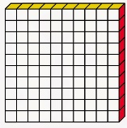 = 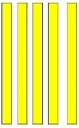  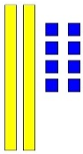  = | Use of bar models to investigate and represent factors. | What are the factors of…?  Is … a factor of …?  Prove that … is a factor of…  What are the common factors of … and …?  What is the highest common factor of …?  What are the prime factors of …?
  32
  12
Division with a remainder | 14 ÷ 3 =  Divide objects between groups and see how much is left over  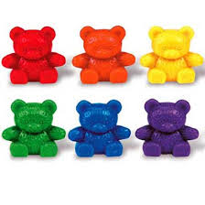 | Jump forward in equal jumps on a number line then see how many more you need to jump to find a remainder.  Draw dots and group them to divide an amount and clearly show a remainder.  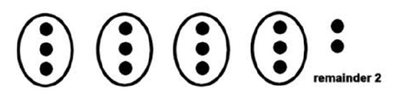  Use a bar model to show divisions with a remainder.  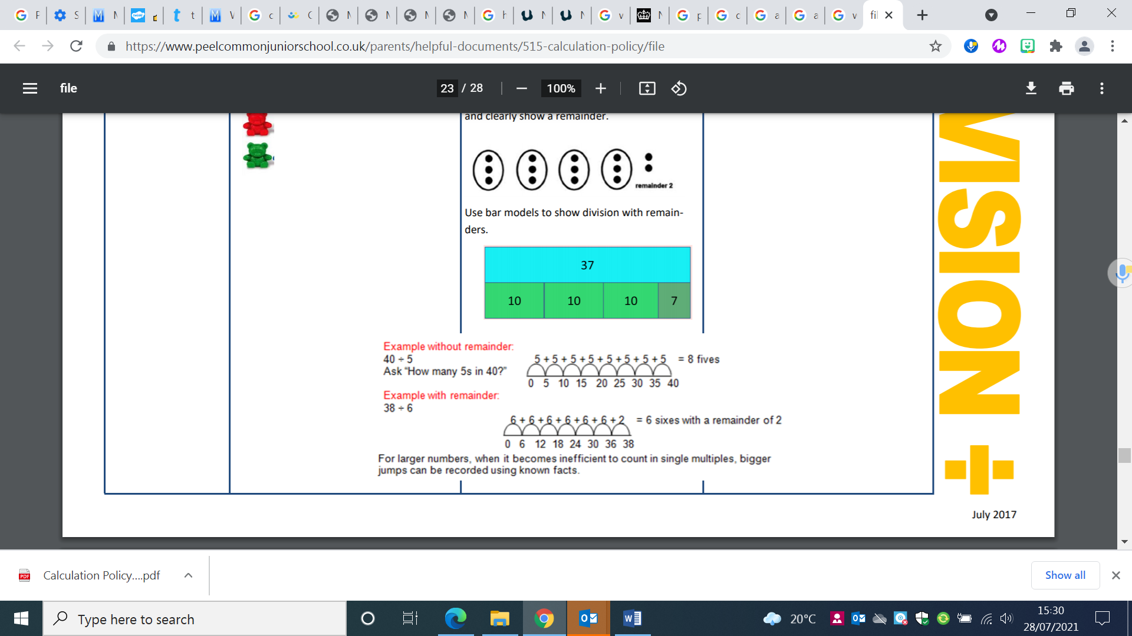 | Complete written divisions and show the remainder using r.  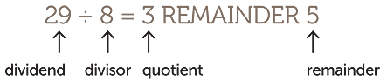  Progress onto writing the remainder as a fraction of the divisor: 3 $\frac{5}{8}$  $\frac{29}{8}$ = 3$\frac{5}{8}$
Long division (to be taught before short division to develop a clear conceptual understanding) | 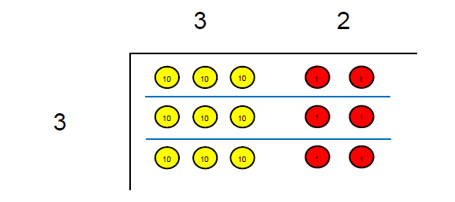  Tens Ones  Use place value counters to divide  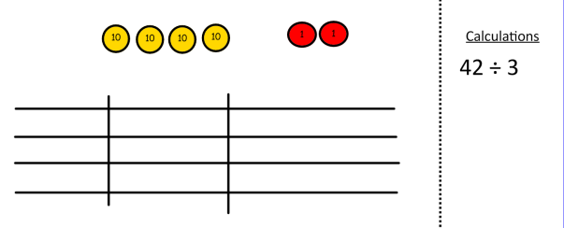  42 ÷ 3=  Start with the biggest place value, we are sharing 40 into three groups. We can put 1 ten in each group and we have 1 ten left over.  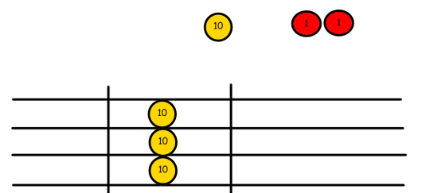  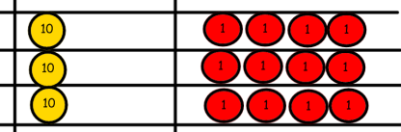  We exchange this ten for ten ones and then share the ones equally among the groups.  We look how much in 1 group so the answer is 14.  Dienes can be used in place of place value counters here. | 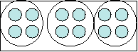  Students can continue to use drawn diagrams with dots or circles to help them divide numbers into equal groups.  Encourage them to move towards counting in multiples to divide more efficiently.  Sticks and dots can be drawn to illustrate and help calculate the division.  Dienes should be represented where exchanging will be necessary.  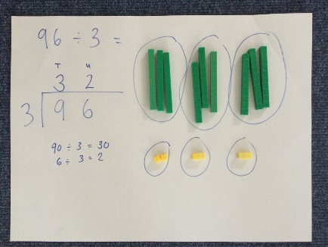 | Begin with divisions that divide equally with no remainder.  From double-digit division by a single digit onwards, the long division method must be used. Colours should be used to show how many times a number goes in, then carry out the subtraction and finally bring down the next digit.  2 8  3 8 4  6  2 4  2 4  0  This can be extended to remainders, represented as a fraction  eg. 85 ÷ 3 = 28 r 1/3  Then the remainder can be represented as a decimal  2 8. 3  3 8 5. 0  6  2 5  - 4  - 0  9  1
Short division | Short division using place value counters to group.  615 ÷ 5 = 123  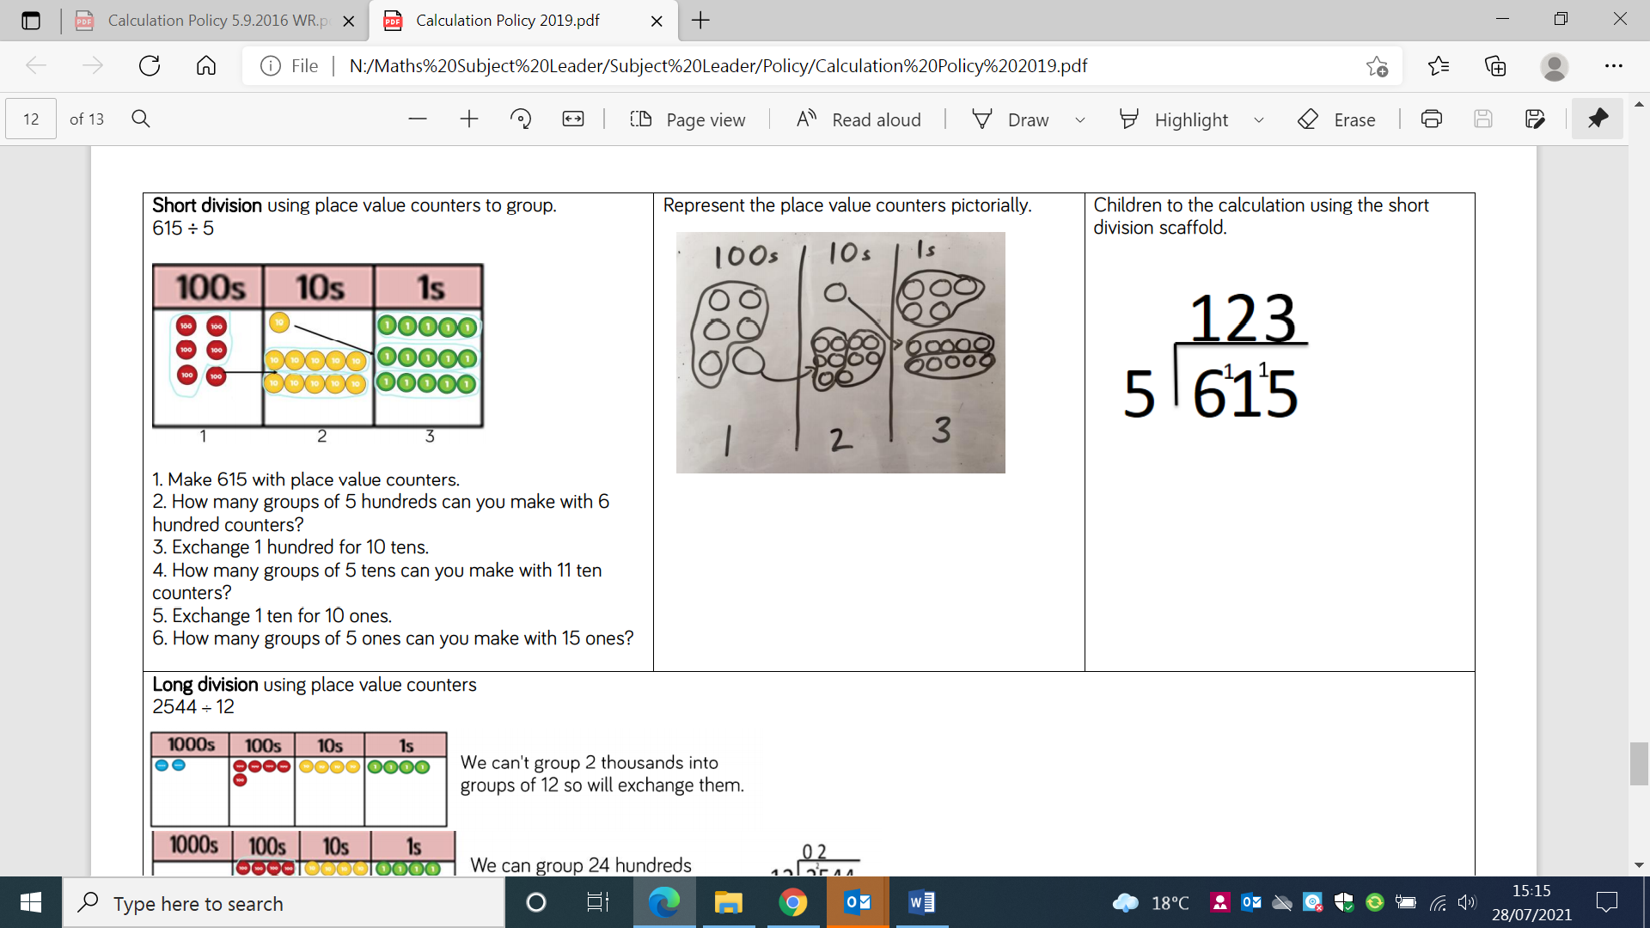  Dienes can be used in place of place value counters. | Represent the place value counters pictorially.  615 ÷ 5 = 123 | Begin with divisions that divide equally with no remainder.  Move onto divisions with a remainder.  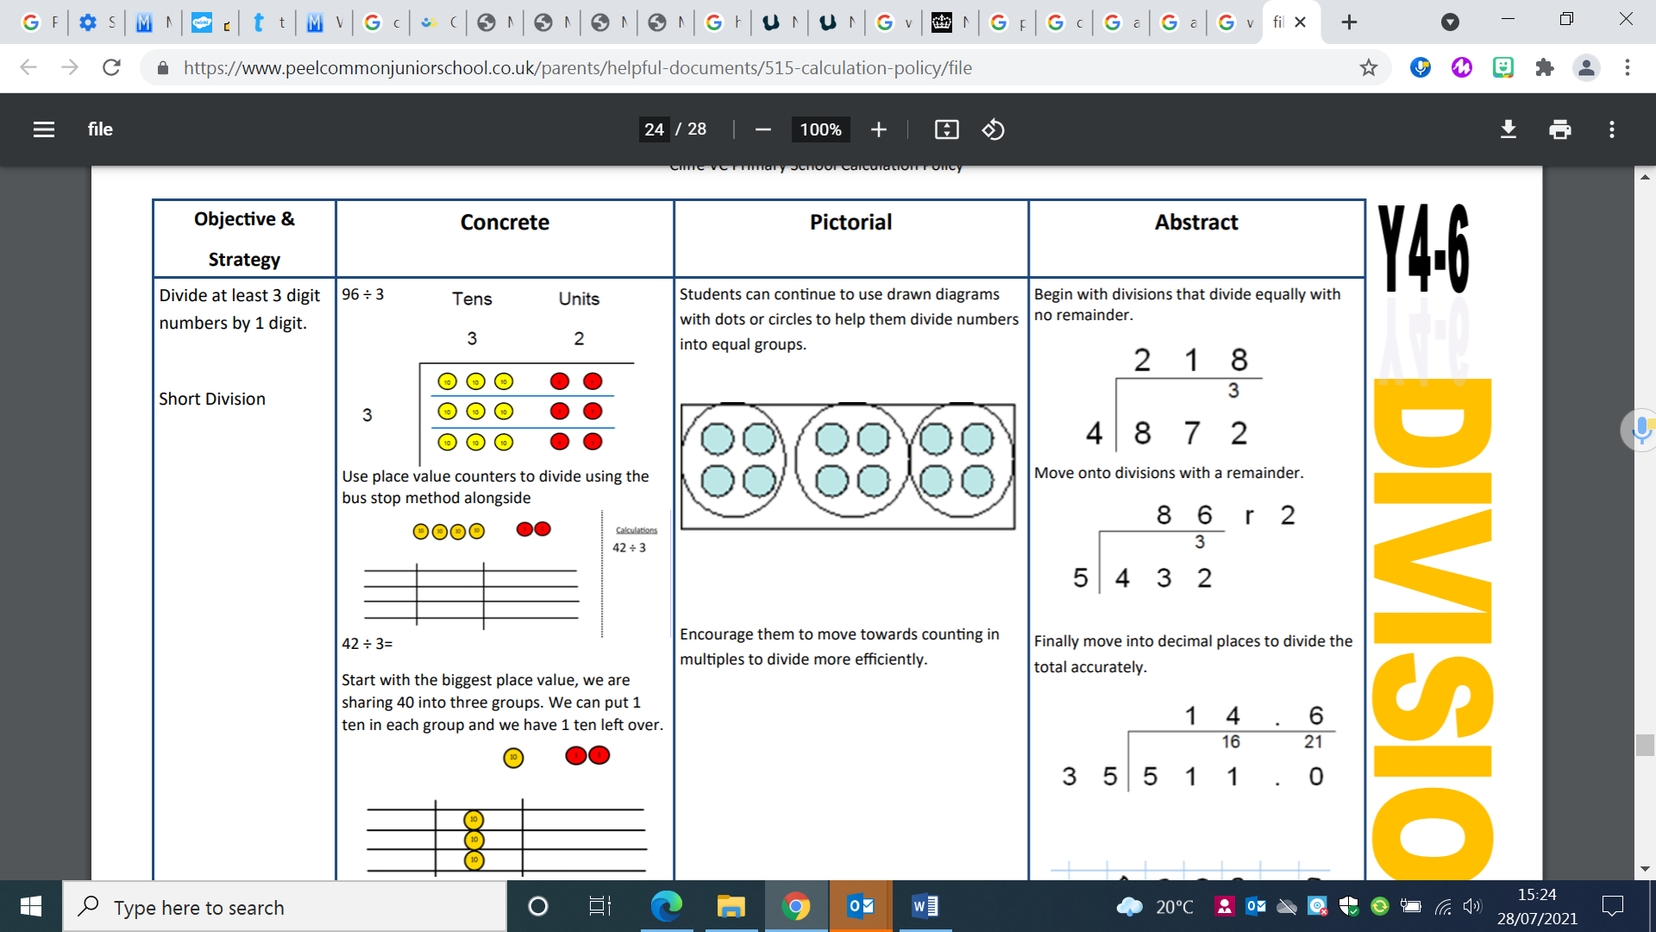  Move into decimal places to divide the total accurately.

