 | Canvey Junior School
 | Special Educational Needs and Disabilities
 | Information Report September 2025
SEND Information | The Children and Families Bill 2013, transformed the system for children and young people with special
 | educational needs (SEND), including those with disabilities, so that services consistently support the best
 | outcomes for them. The SEND system extends from birth to 25, giving children, young people and their
 | parents/carers greater control and choice in decisions and ensuring that their
 | needs are properly met.
School Vision | At Canvey Junior School every child matters.
 | Canvey Junior School provides a safe, caring stimulating community which instils the desire to learn, the will to
 | succeed and the confidence to share talents and experiences.
 | Our school is an inclusive school where every child matters; we aim to address children’s needs and support
What kinds of Special | their development in the most appropriate way possible and celebrate effort as much as achievement. Our
Educational Needs is | school’s SEND policy document is available on this website, detailing our philosophy in relation to SEND.
provision made for at Canvey
Junior School? | Additional and/or different provision is made in school for children with a range of needs,
 | including:
 | • Cognition and Learning – Moderate learning difficulties; Specific learning difficulties - dyslexia, dyspraxia.
 | • Sensory, Medical and Physical – hearing impairment, sensory processing difficulties, epilepsy.
 | • Communication and Interaction – autistic spectrum condition, Asperger’s Syndrome, selective mutism,
 | speech and language difficulties.
 | • Social, Emotional and Mental Health – attention deficit hyperactivity disorder

Canvey Junior School

Special Educational Needs and Disabilities

Information Report September 2025

What is our policy with regard to the identification and assessment of children with SEND?
Please see our SEND Policy, available on the school website.

The SENCO for the school is Ms Alison Lince, and the SEND Manager is Mrs Nicola Bainbridge.
Children with SEND are identified by the following means:
  - Already identified by previous school (Infant School)

- • Concerns raised by Parents, Class Teachers, or the child

  - Concerns raised by other professionals and/or outside agencies
  - Limited progress being made
  - Analysis of termly assessment tests
We may use further assessments to obtain further understanding of a child’s learning difficulties for example:
- Hertfordshire Reading Test
Language Link Screening Assessments
- Dyslexia Screening Test
Star Reader Assessment
Wellbeing and Attitudes towards learning assessment tool
The school promotes a graduated approach to assessing, identifying and providing for pupils’ special educational needs. This approach follows a model of action and intervention to help children make progress and successfully access the curriculum. It recognises that there is a continuum of SEND and that where necessary increasing specialist expertise should be involved to address any difficulties a child may be experiencing.

Throughout Key Stage 2 the children are assessed against nationally set criteria to check their progress across all areas of learning / subjects. It is through this process that children who are not making expected progress are highlighted. Teachers and support staff play a vital role in raising concerns about other barriers to learning, such as behavioural, social and emotional matters.

A rigorous assessment procedure to track children’s progress is continuously used. If a child fails to make expected progress the next stage would be to move to the use of school intervention and/or outside agency involvement for the identification, assessment and recording of children’s learning difficulties. We incorporate these procedures into our normal working practice.

Canvey Junior School

Special Educational Needs and Disabilities

Information Report September 2025

 | Following assessment and staff consultation a child’s special needs are identified and the needs are recorded
 | on the SEND Register.
 | A One Plan is devised in collaboration with the child. The One Plan is sent to parents who are
 | Invited to discuss this initially with the Class Teacher and contribute to the One Plan.
 | Teachers may be supported by specialists from outside school who can meet with parents and school staff.
 | Class Teachers have responsibility for enabling all pupils to learn.
What provision is available | To achieve this they:
for children with SEND at our | • | plan appropriate work / activities for their pupils
school? | • | ensure that support is available for all children (inclusive ‘quality first’ teaching)
 | • adapt the curriculum to take account of different learning styles, interests, abilities
 | • ensure that all children can be included in tasks / activities
 | • | monitor individual progress
 | • | celebrate achievement
 | • identify those children who require additional or different support in order to make progress
 | • set targets and discuss these with parents and pupils
 | Support Staff
 | • through ‘quality first’ teaching, support the teachers in enabling all children to have access to
 |  | the teacher
 | • support the teachers in enabling children with SEND to have access to an appropriate curriculum
 | • | encourage and promote independence in the children
 | • liaise with the Class Teacher
 | • | help to prepare resources and adapt materials
 | • lead interventions to close the gap for children experiencing difficulty
 | • Promote the inclusion of all children in all aspects of life at school.

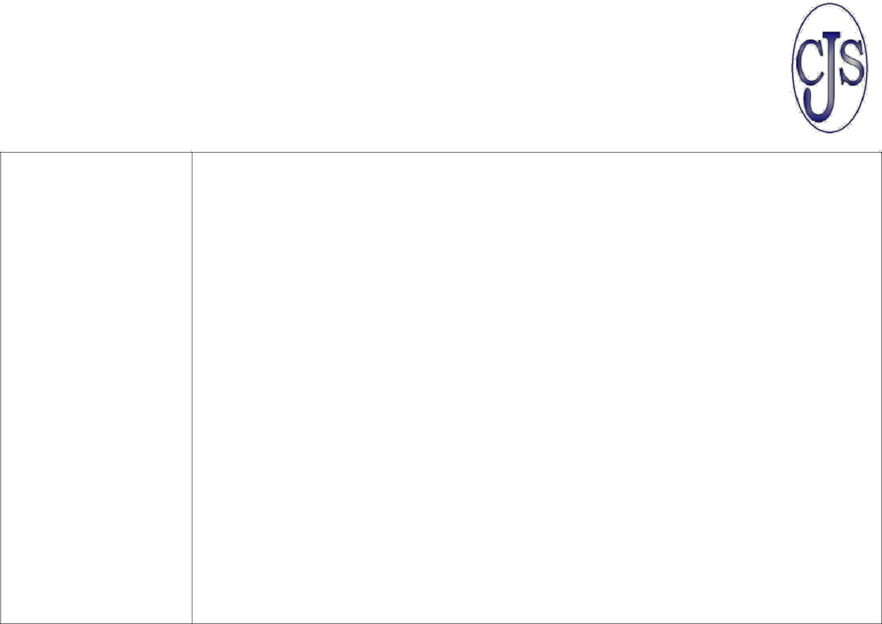
Canvey Junior School

Special Educational Needs and Disabilities

Information Report September 2025

INTERVENTION:

Intervention is carried out by the school and is ‘additional to or different from’ the usual adapted curriculum. It can take the form of:

- using different learning materials in the classroom

- making reasonable adjustments within the physical environment
- making reasonable adjustments to routines
- Support Staff in the classroom

- a more focused level of support in a small group/1:1 withdrawn from the class
- focused work to be completed at home

At any time according to need, a combination of any of the following strategies may be in place as part of the interventions:

- TT Rockstars computer programme
- English and/or maths booster group

- Group work to develop English and maths skills
• Social skills and emotional literacy groups

- Soft landing

- Sensory Room

- Referrals/involvement of outside agencies
- Anti-bullying workshops

- Involvement of outside agencies when appropriate
- Play/Art therapy sessions and access to a counsellor

- All staff are available for pupils who wish to discuss any issues or concerns they may have
- Speech and Language intervention
- Group wellbeing sessions with SEND Manager
Accelerated Reader Intervention

 | Canvey Junior School
 | Special Educational Needs and Disabilities
 | Information Report September 2025
What arrangements are in | • Sonar is used to track progress and attainment
place for assessing and | • Ongoing assessments against age related National Curriculum expectations
reviewing progress of | • Observations/Assessments from Specialist Teachers and Educational Psychologist
children with special | • Progress in emotional, social and behavioural development assessed through observations and
educational needs? | feedback from teachers, support staff and parents
 | • Annual review for children with EHC plans
 | • Interventions are reviewed termly
How do we evaluate the | • Termly analysis of outcome of interventions implemented
effectiveness of provision | • Parents involved in assessing effectiveness of the provision for their child at review meetings
provided to support children | • Termly assessments
with SEND? | • Pupil progress meetings with class teacher’s and SENCO
 | See Accessibility policy (a copy can be accessed via the school office)
How children with SEND | • Activities and school trips are available to all pupils
access out of school | • Risk assessments are completed for all trips/activities, and any necessary procedures implemented to
activities and the school | enable all children to take part
building? | • School is fully wheelchair accessible, with disabled facilities
 | • There is one designated disabled parking bay
 | • Some specialist equipment and facilities for children with specific needs are secured via the local
 | authority.

 | Canvey Junior School
 | Special Educational Needs and Disabilities
 | Information Report September 2025
 | • Local SEND cluster networks provide support throughout the year
How do we train and | • Regular training for SENCO and SEND Manager
support our staff to ensure | • Joint training with partner Infant School
the education and welfare | • Inset training days/staff meetings in areas relating to specific needs either by SENCO or outside
of our learners? | specialists e.g. speech and language, autism, ADHD, Sensory Needs, Managing Anxiety,
 | • Certified First Aid Training for staff
 | • Training for staff to support children with medical needs e.g. anaphylaxis, diabetes, asthma
 | • School employs a team of LSAs who are trained to deliver a range of interventions on a small group and
  - Basis
- Some staff trained to carry out Draw and Talk
- Staff are trained to support Speech and Language via Language Link on line programme
- Staff are trained to support reading and comprehension progress via Accelerated Reader Programme
 | • Costs are identified for support staff in annual budget.
How is equipment and | • Inclusion Partner and educational psychologist support secured through the local authority.
facilities to support children | • The money for SEND is used to provide additional support, or resources, dependant on an individual
with SEND secured? | child’s needs.
 | • Additional provision may be allocated following discussions with class teachers/head teacher in pupil
 | progress meetings or if a concern is raised at another point during the year.
 | • Induction Pack sent to new Year 3 parents in the summer term prior to the children starting at Canvey
What are the arrangements | Junior School  - Transition visits for Year 3 pupils and their parents during the Summer term
for consulting parents of | • Pre-Admission meeting with SEND Manager available
children with SEND | • Termly Parent Interviews with Class Teacher and/or SEND Manager
 | • ½ termly contact with class teacher and meetings when required in addition
 | • An ‘open door’ policy whereby the SEND Manager is easily contactable via the school office/telephone.

 | Canvey Junior School
 | Special Educational Needs and Disabilities
 | Information Report September 2025
 | • Annual Review meetings for children with EHC Plans
 | • On some occasions regular meetings are also offered to ensure good communication between home
 | and school
 | • Annual report sent to parents in the Summer Term, interim reports sent in Autumn and Spring Terms.
What are the arrangements | • Targets are reviewed with the children
for consulting children with | • Views of children receiving additional SEND support are recorded at review time
SEND and involving them in | • One Page Profile updated annually
their education? | • Self- evaluation during lessons against differentiated success criteria.
What are the arrangements | • Excellent links with our feeder and transfer schools means that transition is very good due to our close
for supporting children | liaison with these schools
transferring between stages | • SEND teams from the Junior and Infant schools liaise throughout the year.
of education? | • Year 6 class teacher and SEND Manager meet with Year 7 Head of Year to pass on information for
 | transition to Senior School.
 | • KS2 SEND records and assessment results passed to relevant Senior school
 | • Additional visits to Senior School arranged as required or requested.
How are complaints from | If you have any queries or concerns regarding your child’s educational needs or the support they are receiving,
parents with children with | please contact the school office to make an appointment with the SEND Manager / SENCO / Headteacher.
SEND managed regarding
provision made at the | If the concern cannot be resolved see Complaints Policy on school website.
school?

 | Canvey Junior School
 | Special Educational Needs and Disabilities
 | Information Report September 2025
The name and contact | The SENCO for the school is Ms Alison Lince and the SEND Manager is, Mrs Nicola Bainbridge.
details of the SENCO and the | Contact details are 01268 682288
SEND Manager. | admin@canvey-jun.essex.sch.uk
Where is the local | Essex County Council: Special Educational Needs and Disabilities (SEND) | Essex Local Offer
authority’s offer published?

